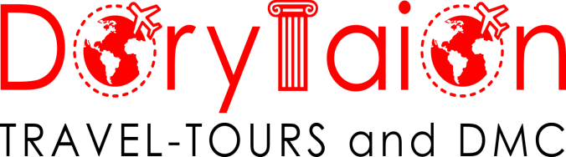

FROM : **SUPREME TRAVEL ATHENS GREECE**

REF OF QT : **9017 ( MAHAN AIRLINE )**

VALIDITY : 15.10.2019 to 05.05.2020

|  |  |  |  |
| --- | --- | --- | --- |
| **NO OF PERSONS** | **IN DBL PP** | **IN TRP PP** | **SINGLE SUPPLEMENT** |
| 15 + 01 PAX | 457 EURO |  | 205 EURO |
| 20 + 01 PAX | 407 EURO |  | 205 EURO |
| 25 + 01 PAX | 373 EURO |  | 205 EURO |
| 30 + 01 PAX | 351 EURO |  | 205 EURO |

**HOTEL OPTIONS:**

|  |  |  |  |
| --- | --- | --- | --- |
| **NIGHTS** | **CITY** | **HOTEL** | **ROOM TYPE** |
| NIGHT 01 | CAPPADOCIA | MUSTAFA 4* or SIMILAR | STANDARD |
| NIGHT 02 | CAPPADOCIA | MUSTAFA 4* or SIMILAR | STANDARD |
| NIGHT 03 | ESKISEHIR | ANEMON 4* or SIMILAR | STANDARD |
| NIGHT 04 | ESKISEHIR | ANEMON 4* or SIMILAR | STANDARD |
| NIGHT 05 | BURSA | GOLD MAJESTY 4* or SIMILAR | STANDARD |
| NIGHT 06 | ISTANBUL | RAMADA ENCORE 4* or SIMILAR | STANDARD |
| NIGHT 07 | ISTANBUL | RAMADA ENCORE 4* or SIMILAR | STANDARD |
| NIGHT 08 | ISTANBUL | RAMADA ENCORE 4* or SIMILAR | STANDARD |

**INCLUDED SERVICES:**

* 08 Nights Hotel Accomodation
* Daily Breakfast
* 8 Lunches at local restaurant
* 8 Dinners at restaurant or hotels
* English Speaking Guide through the itinerary
* Airport Transfers
* Transportation by modern A/C vehicle according to group size
* Entry fees to the mentioned sites in below itinerary

**EXCLUDED SERVICES:**

* Speddy Train Konya – Eskisehir **12 euro**
* Personal Expenses
* All International & Domestic Flight Tickets
* Drinks at Meals
* Tips for Guide & Driver (PP perday 3 EURO for Guide & PP perday 2 EURO for Driver)
* Visa & Insurance
* Porterage at Hotels & Airports
* City Taxes
* Any other services not mentioned above
* Domestic ticket ( Estimated )

**GENERAL NOTES:**

* All rates are net to yourside in EURO and all rates have been calculated on the present VAT. Should the latter increase, prices will be adjusted accordingly.
* Rates are not valid for the bookings made in Fair or Exhibition or New Year or Any National Day periods. Supplement may apply during these periods.
* No luggage will be loaded inside the coach. This is a matter of PASSENGER SAFETY REGULATIONS (imposed by the local authorities as well as all insurance companies), if coach is stopped and checked by the police we will end up paying a considerable fine and coach driver might be forced to interrupt the tour till luggages are off-loaded.

**Itinerary**

**7 CAPITAL CITIES ( NEW TV SERIAL ERTUGRUL )**

**1 new + 6 old capital cities of Turkish History**

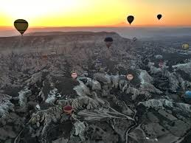 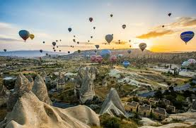

**Day 1 KL – Tahran – Ankara – Cappadocia**

After arrival Ankara we visit Mozoleum of Mustafa Kemal and Haji Bayram Mosque. After we drive bus Cappadocia. On the way we stop SALT LAKE.

**Day 2 Cappadocia**

Goreme’s rock chapels decorated with 6th century frescoes, Zelve’s cliff-side Byzantine monastic complex and Uchisar’s natural citadel. Today we visit carpet companybefore afternoon. Explore the eight-story underground city of Kaymakli where thousands of early Christians hid from persecutors. Afternoon we visit also Handmade Ceramic factory. we will visit Avanos Pasabaglar cavusin lunch for local home made food. Before Afternoon we visit Handmade Onyx-gold and silver atelier.

Optional Turkish Night. Dinner and overnight in Cappadocia.

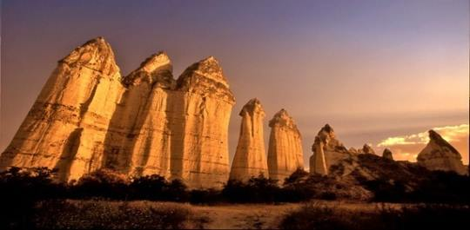

**Day 3 Cappadocia - Konya – Eskisehir**

After breakfast drive Ihlara Valley. After visit IHLARA VALLEY and drive Konya.On the route ve visit most important KERVANSARAY of SELCUKLU empire name is SULTANHAN. Konya was the capital city of Turk

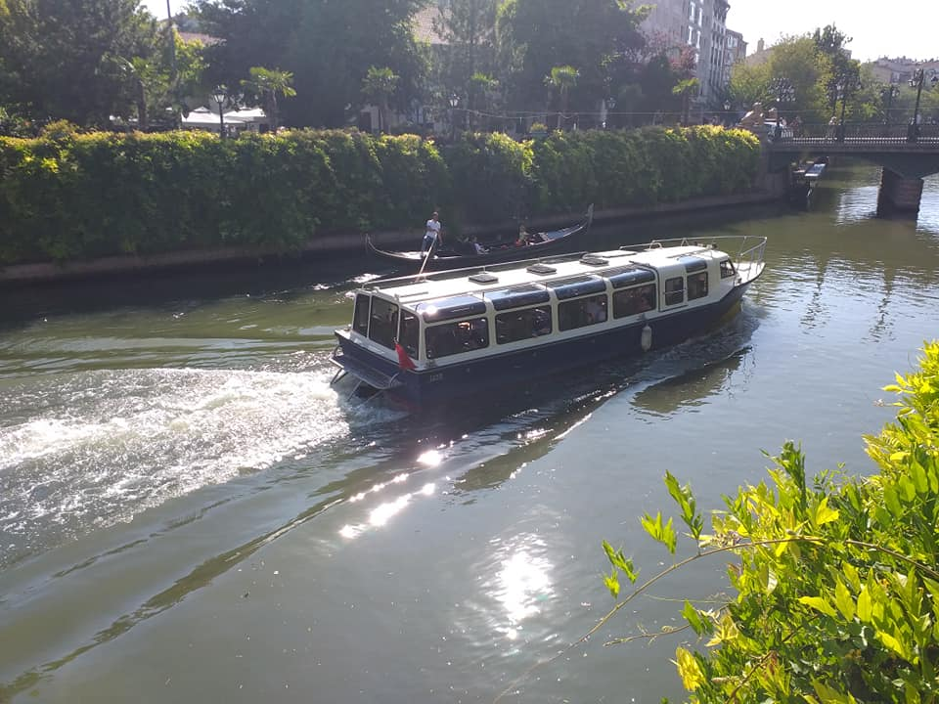

Selcuklu Emperior. In Konya visit the famous mausoleum of the Sufi philosopher, Mevlana. This was also the dervish lodge of the Mevlevi order, better known as the Whirling Dervishes. Afternoon we take Speedy train and go to Eskisehir. Transfer to hotel dinner and leisure time.

**Day 4 Eskisehir**

Morning we have TURKISH HAMAM tour. We will go hot spring water hamam and we enjoy the early morning. After hamam we make our breakfast and begin to make city tour. Our first stop Kentpark. Major of Eskisehir made this park beach. At the summer time Eskisehir citizens swim there. After beach park we drive bus old city of Eskisehir called Odunpazar. We visit Kursunlu mosque and Kulliyesi ( Old Islamic university ), Atlihan hand cradt bazaar, Wax museum, We make lunch stop and afternoon we visit Esminiaturk , Sazova park and our last stop Adalar. We will make Boat tour at river. Late afternoon we return at hotel.

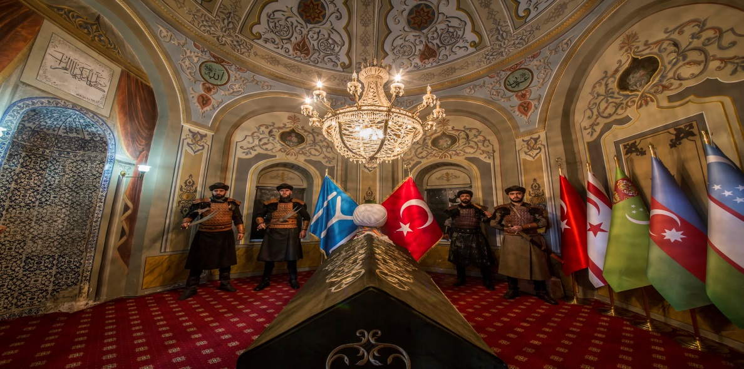

**Day 5 Eskisehir – Sogut – Bursa**

Aftr breakfast we drive bus first Ottoman capital city name is Sogut. Ottoman was born there. We will visit Ertugrul mosoleum and tomb of Dursun fakih.. After lunch we drive bus Bursa.Bursa is the second capital city of Ottoman. Green mosque, Koza han, Hacivat- Karagoz tomb,Ulu cami, Tomb of Osman and Orhan gazi. After our tour we transfer to hotel and dinner at hotel.

**Day 6 Bursa – Iznik- Istanbul**

After breakfast we drive bus Iznik. One of the capital city of Ottoman but Iznik has very important history of christianism. Bible is quartered as Matthew, markos, Luke, and John. when you go to the place called iznikin inciraltı, you can see the remains of the collected place. And also Concil take decision of EASTER holy day. We visit Hagia Sofia of Izmit , Green Mosque and Suleyman Pasa Madrasa.

**Day 7 Istanbul**

After breakfast We visit. Blue Mosque.. which is the second largest mosque in Istanbul, built to compete with St. Sophia. Dating back from 17 th century. Mosque is Famous for its blue tiles and 6 minarets. Hippodrome Square former centre of sportive and political activities of Constantinople. See the famous Egyptian Obelisk, Serpentine Column and Wilhelm II fountain. Visit St. Sophia, which has been a cathedral and a mosque, now is a magnificent museum. Its mosaics, stained glass windows &amp; decorated domes create an atmosphere of breath taking beauty. Afternoon we visit also Sulemaniye mosque.Dinner and transfer to your hotel. Overnight in Istanbul.

**Day 8 istanbul – Edirne – Isstanbul**

Today we have daily Edirne tour.Edirne is the one of capital city of Ottoman also. After conquest of west Anatolia Ottoman soultans pass the Trakhi. When they conquest Edirne they transfer to capital city Bursa to Edirne, Untill Istanbul Conquest ( 1453 ) Edirne was 92 year capital city of Ottoman. We will visit Selimiye Mosque, Muradiye Mosque, Complex of Sultan Bayezid 2 health museum, Meric Bridge, Edirne Palace, Grand bazaar of Edirne, Late afternoon return at Istanbul

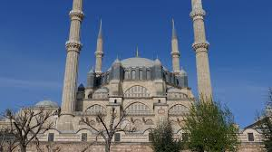 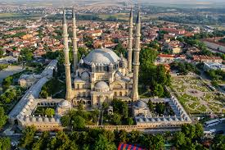.

**Day 9 Istanbul - Tahran - KL**

After breakfast we transfer to Airport